

**Tech Saksham**

Case Study Report

**Data Analytics with Power BI**

***“ANALYSIS OF COMMERCIAL ELECTRICITY CONSUMPTION IN INDIAN STATES”***

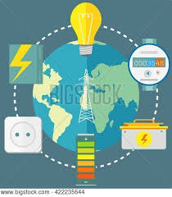

|  |  |
| --- | --- |
|  |  |
|  |  |
|  |  |

**V. O. Chidambaram College**

**Thoothukudi**

|  |  |
| --- | --- |
| **NM ID** | **NAME** |
| E7E04A2642E7176AECC4D184D482B2FC | ZAHEEKHA FAZLIN B |

**Trainer Name:** UMAMAHESHWARI

**ABSTRACT**

The proposed project, “Analysis of Commercial Electricity Consumption in Indian states. This analysis explores the patterns and trends in electricity consumption across various states in India. Using a dataset comprising historical electricity consumption data, we employ data visualization techniques to examine how electricity usage varies geographically and over time. The study includes the visualization of commercial electricity consumption patterns, trends, and distribution among different states in India. Through the analysis of bar charts, line charts, and map visualizations, we aim to provide insights into the factors influencing electricity consumption, such as economic development, industrialization, population density, and regional policies by using PowerBI. The findings of this analysis contribute to a better understanding of the dynamics of electricity consumption in India, which can inform policy-making, infrastructure planning, and energy management initiatives.

**INDEX**

|  |  |  |
| --- | --- | --- |
| **Sr. No.** | **Table of Contents** | **Page No.** |
| 1 | Chapter 1: Introduction | 1 |
| 2 | Chapter 2: Services and Tools Required | 4 |
| 3 | Chapter 3: Project Architecture | 5 |
| 4 | Chapter 4: Modeling and Result | 7 |
| 5 | Conclusion | 18 |
| 6 | Future Scope | 19 |
| 7 | References link | 21 |
| 8 | Link |  |

**CHAPTER 1**

**INTRODUCTION**

* 1. **Problem Statement**

The objective of this project is to analyze and visualize the commercial electricity consumption patterns across various states in India using Power BI. The analysis aims to provide insights into the trends, fluctuations, and factors influencing commercial electricity usage, aiding stakeholders in making informed decisions related to energy planning, infrastructure development, and policy formulation.

* 1. **Proposed Solution**

The proposed solution is to develop a PowerBI dashboard. It is a dynamic and user-friendly dashboard will be created using Power BI. This dashboard will present key insights and visualizations related to commercial electricity consumption in Indian states. It will include interactive features to allow users to explore data and gain deeper insights into consumption patterns. Creating interactive dashboards within Power BI to allow users to explore and drill down into the data, enabling stakeholders to gain insights, identify outliers, and make data-driven decisions based on real-time information.

* 1. **Feature**

**Data Modeling:** Developing a robust data model within Power BI to organize and structure the commercial electricity consumption data, enabling efficient analysis and exploration of relationships between various factors influencing consumption.

**Data Preparation:** Cleansing and preprocessing the raw data to ensure accuracy and consistency, including handling missing values, standardizing units, and formatting dates for seamless integration into Power BI.

**Geospatial Analysis:** Leveraging Power BI's mapping capabilities to perform geospatial analysis, visualizing commercial electricity consumption data on maps to identify regional variations and hotspots of consumption within Indian states.

**Time-Series Analysis:** Conducting time-series analysis to identify seasonal trends, fluctuations, and long-term patterns in commercial electricity consumption over time, using Power BI's features for time-based visualization and trend analysis.

**Comparative Analysis:** Utilizing Power BI to perform comparative analysis between different states, industries, or time periods to identify disparities, similarities, and factors influencing commercial electricity consumption across regions.

**Insights Generation:** Extracting actionable insights from the analysis to inform policymakers, energy regulators, utility companies, and businesses about strategies for optimizing energy usage, enhancing efficiency, and promoting sustainability in commercial sectors across Indian states.

* 1. **Advantages**

**Real-time Insights:** Power BI can be configured to update dashboards and reports in real-time, enabling users to monitor electricity consumption trends and make timely decisions based on the latest data.

**Predictive Analytics:** Power BI offers advanced analytics capabilities, such as forecasting and trend analysis, allowing users to predict future electricity consumption patterns and plan accordingly.

**Collaboration:** Power BI facilitates collaboration among team members by allowing them to share dashboards, reports, and insights, fostering better communication and decision-making.

* 1. **Scope**

Examining the general trends in commercial electricity consumption across different states over time. Comparing consumption patterns between states or regions to identify outliers or areas of interest. Analyzing how electricity consumption varies with seasons in different states, which can be crucial for resource planning and management. Breaking down consumption by industry sectors such as manufacturing, services, etc., to understand specific consumption patterns. Identifying peak consumption periods and understanding the factors contributing to peak demands. Analyzing load distribution across different times of the day to optimize energy distribution and infrastructure planning. Exploring the relationship between commercial electricity consumption and economic indicators such as GDP growth, industrial production, etc. Assessing the impact of government policies, regulations, or incentives on electricity consumption patterns. Using historical data to forecast future electricity consumption trends and demand. Evaluating the effectiveness of energy efficiency measures or campaigns in reducing electricity consumption.

**CHAPTER 2**

**SERVICES AND TOOLS REQUIRED**

**2.1 Services Used**

* **Data Collection:** Gather data on commercial electricity consumption in Indian states from reliable sources such as government reports, energy regulatory commissions, or power distribution companies.
* **Data Cleaning and Preparation:** Clean it by removing any duplicates, inconsistencies, or missing values. Ensure that the data is structured properly with columns for state, consumption, date, etc.
* **Data Modeling:** Create relationships between different tables if you have multiple datasets. Define measures and calculated columns that will be used in your visualizations.

**2.2 Tools and Software used**

**Tools**:

* **PowerBI**: The main tool for this project is PowerBI, which will be used to create interactive dashboards for real-time data visualization.
* **Power Query**: This is a data connection technology that enables you to discover, connect, combine, and refine data across a wide variety of sources.

**Software Requirements**:

* **PowerBI Desktop**: This is a Windows application that you can use to create reports and publish them to PowerBI.
* **PowerBI Service**: This is an online SaaS (Software as a Service) service that you use to publish reports, create new dashboards, and share insights.
* **PowerBI Mobile**: This is a mobile application that you can use to access your reports and dashboards on the go.

**CHAPTER 3**

**PROJECT ARCHITECTURE**

**3.1 Architecture**

* **Data Sources:** The first step is to identify and gather relevant data sources containing information about commercial electricity consumption in Indian states. These sources may include government databases, utility companies' records, industry reports, and external data providers.
* **Data Preparation:** Once the data sources are identified, the data needs to be collected, cleaned, and transformed into a format suitable for analysis. This may involve data cleansing, normalization, and integration to ensure consistency and accuracy.
* **Data Storage:** The prepared data is then stored in a data repository or data warehouse. Depending on the volume and complexity of the data, organizations may use on-premises databases or cloud-based solutions such as Microsoft Azure SQL Database or Amazon Redshift.
* **Data Modeling:** In this step, a data model is created to define the relationships between different data entities and optimize data retrieval for analysis. Power BI supports various data modeling techniques, including star schema and snowflake schema, to organize data effectively.
* **Data Refresh and Automation:** To ensure that the analysis is based on the latest data, organizations can set up automated data refresh schedules in Power BI Service to periodically update the dashboards and reports with new data from the data sources.
* **User Access and Training:** Finally, organizations need to provide access to the Power BI dashboards and reports to relevant stakeholders, such as energy analysts, policymakers, and business leaders. Training and documentation may also be provided to help users understand how to interact with the dashboards and derive insights from the data.

By following this project architecture, organizations can effectively leverage Power BI to analyze commercial electricity consumption data in Indian states and derive valuable insights to support decision-making and resource planning initiatives.

**CHAPTER 4**

**MODELING AND RESULT**

**Dashboard**

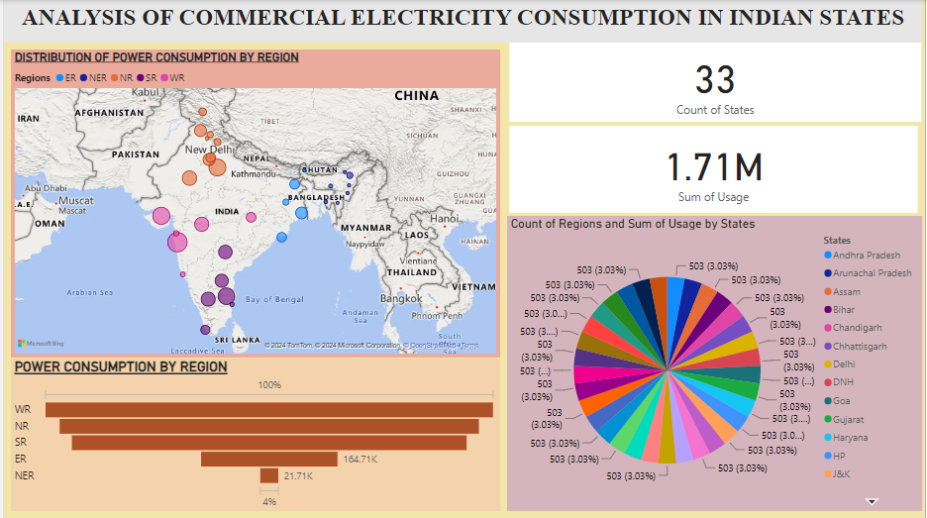

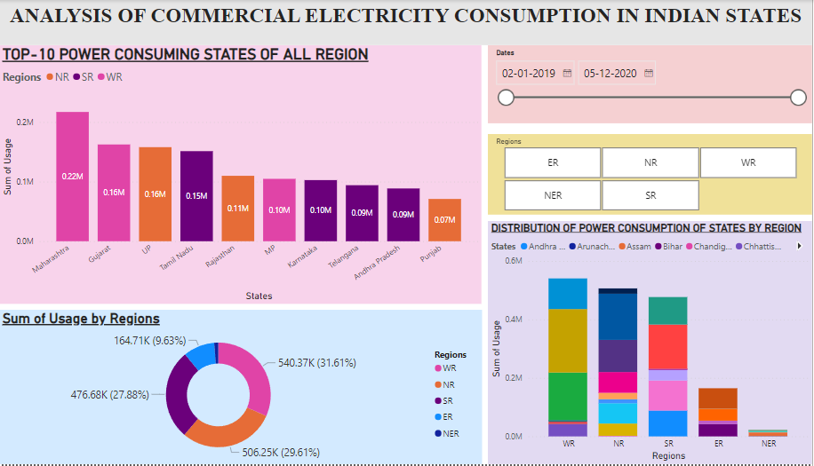

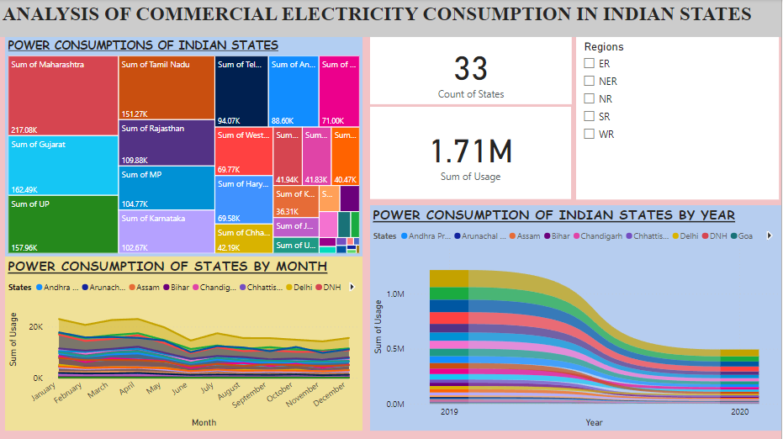

**CONCLUSION**

The project “Analysis of Commercial Electricity Consumption in Indian States” using PowerBI has successfully demonstrated the potential of data analytics. There may be observable seasonal patterns in electricity consumption, influenced by factors such as climate, economic cycles, and festivals. Significant variations exist in commercial electricity consumption across different states, highlighting potential disparities in economic activity and development. States with higher consumption rates may benefit from targeted energy efficiency programs to reduce wastage and improve sustainability. Businesses can use this data to identify market opportunities and tailor their offerings to meet the specific needs of high-consumption regions. Overall, leveraging PowerBI for analyzing commercial electricity consumption in India states provides valuable insights for stakeholders to optimize energy usage, enhance infrastructure planning, and promote sustainable development.

**FUTURE SCOPE**

The future scope of this project is vast. With the advent of advanced analytics and machine learning, PowerBI can be leveraged to predict future trends based on historical data. Compare electricity consumption patterns among different states to understand variations and factors influencing consumption. Analyze consumption data to identify areas for cost optimization and efficiency improvements, such as reducing wastage or implementing energy-saving measures. Implement strategies for managing electricity demand during peak hours or periods of high consumption to mitigate grid stress and minimize costs. Identify patterns and trends in commercial electricity consumption over time to anticipate future demands and plan accordingly. Evaluate the impact of sustainability initiatives on electricity consumption and identify opportunities for further sustainability efforts. Ensure compliance with regulatory requirements by monitoring and reporting on electricity consumption data accurately. Inform policy-making processes by leveraging data insights to develop effective energy policies and regulations aimed at promoting sustainable consumption practices. Generate comprehensive reports and dashboards to communicate insights to stakeholders, such as government agencies, utilities, and businesses, for informed decision-making.

**Reference link**

<https://www.kaggle.com/datasets/twinkle0705/state-wise-power-consumption-in-india>